**1. ABOUT THE PROBLEM**

…………..

Earlier, when mailing was not available, postal system and telephone were used to inform and share notice to a student and college staff that is time consuming so the student and staff does not receive notice in a proper time, so that this type of communication not effective and efficient.

@mps mailing system is much better than the manual system as it has following advantages:

* Time saving
* Increased efficiency
* Cheaper and less manpower (only you!) to maintain.
* Provide Security
* Online anywhere access.

**EXISTING SYSTEM**

* Lack of security of Data.
* Cost of postal system.
* Time consuming.
* Difficult to maintain old record.
  1. **OBJECTIVE**

Today’s world is all depend upon email system. It also becomes a significant need of the college. That’s where, Student must know mailing system and aware with that, how it works. The main objective of @mps mail system is to provide a official platform in a college where student communicate with teacher and student and also share document. In this system teacher notify student of upcoming seminar, exam, important notices, and special events through mail to a particular branch student. @mps mail system provide a good interface where student use all features with easily manner.



* 1. **FEASIBILTY STUDY**

Feasibility study is an assessment of the practicality of a proposed project.

A feasibility study aims to objectively and rationally uncover the strengths and weaknesses of an existing business or proposed venture, opportunities and threats present in the environment, the resources required to carry through, and ultimately the prospects for success. In its simplest terms, the two criteria to judge feasibility are cost required and value to be attained.

A well-designed feasibility study should provide a historical background of the business or project, a description of the product or service, accounting statements, details of the operations and management, marketing research and policies, financial data, legal requirements and tax obligations. Generally, feasibility studies precede technical development and project implementation.

Common factors:

There are five areas of feasibility - Technical, Economic, Legal, Operational and Scheduling.

Technical feasibility:

The technical feasibility assessment is focused on gaining an understanding of the present technical resources of the organization and their applicability to the expected needs of the proposed system.

Economic feasibility:

The purpose of the economic feasibility assessment is to determine the positive economic benefits to the organization that the proposed system will provide. It includes quantification and identification of all the benefits expected. This assessment typically involves a cost/ benefits analysis.

Legal feasibility:

Determines whether the proposed system conflicts with legal requirements, a data processing system must comply with the local data protection regulations and if the proposed venture is acceptable in accordance to the laws of the land.

Operational feasibility:

Operational feasibility is a measure of how well a proposed system solves the problems, and takes advantage of the opportunities identified during scope definition.



**2. INTRODUCTION**

…………..

**2.1 DEFINITION**

Mailing System is a web application implemented using Python framework Django and uses MySQL as the system database. By using mail system you can send emails to your friends, who are registered with that system. It allows a user to send text and data like picture, files, video, mp3, etc.

In mailing system, a user can register himself. After registration, they can login with their user id and password. The mailing system allows the user to customize their profile, change themes as per own interest. Mailing system is also a very secure system. It provides you security as you needed your profile is protected with a password. You can change the password when you feel insecure with the old password. There is also the password recovery system in case you forgot your password you can recover your profile by verifying your security question. The exiting user are needed to authentication their identity and then they permitted to check their mail in their mailbox. Also they can send mail. You can delete the necessary mail from mailbox. A good user interface has been provided for performing all these task easily.



**2.2 FEATURES**

@mps mailing system must be able to do these functions

* Compose an email.
* Send an email
* Receive an email
* Showing the detail of the received mail
* Search facility based on various factors such as subject, message data and mail address.
* User can update profile detail and pic.
* Get Notification (if someone send mail, if you change password or profile detail)
* Secured by Password
* Recovery of Password

**2.3 PROJECT USERS**

1. **Admin**: Administrator can manage, monitor and control the entire mail system. They can see user profiles, list of mail ids available in the database, and respond to queries sent by users.

2. **Users**: User is use the whole facility of mail System. User also contact to admin if any problem is face by sending mail to support@mps.edu.

**2.4 PROJECT MODULES**

**Admin: -** **User:-**

Login Registration

Manage User Login

Compose Mail Compose Mail

Inbox Inbox

Sent Mail Sent Mail

Delete Mail Delete Mail

Log Out Log Out

**2.5 PROJECT REQUIREMENTS**

**HARDWARE REQUIREMENTS**

* Intel Core Processor.
* GB RAM with minimum 1 GB hard disk free space.
* Monitor.
* Mouse.
* Keyboard.

**SOFTWARE REQUIREMENTS**

* Windows 7, 8, 10 (32, 64 bit)
* IDE: Sublime Text Editor
* Back End: Python 3.7
* Browser: Google Chrome, Mozilla Firefox



**3. SYSTEM DESIGN**

…………..

**3.1 USE CASE**



LOGIN

MANAGE USER

COMPOSE MAIL

INBOX

SENT MAIL

ADMIN

SAVE MAIL

DELETE MAIL

LOG OUT

#### 3.2 Admin Use Case



REGESTRATION

LOGIN

COMPOSE MAIL

INBOX

SENT MAIL

USER

SAVE MAIL

DELETE MAIL

LOG OUT

3.3 User Use Case

**DATA FLOW DIAGRAM**

**3.4 Context Level Diagram (Level 0)**



Successed or Error

ADMN

MPS

MAILING SYSTEM

USER

**3.5 DFD Level 1**



USER DB

MPS MAILING SYSTEM

AUTHENTICATI

ON

REGESTRATION

LOG IN

USER

MAIL SERVER



* 1. **DFD Level 2**





UPDATE INFO PROFILE PRP

Starred MAIL

PROFILE

INFO

NOTIFICATION

Mail DB

DELETE MAIL

SEND MAIL

MAIL

MAIL

COMPOSE T Receive

USER

# 5. TABLES

#### Tbl_Profile:

…………..

|  |  |  |  |
| --- | --- | --- | --- |
| **Field** | **Datatype** | **Null or/Not Null** | **Description** |
| **Id** | **Int** | **Not Null** | **Primary Key** |
| **User** | **Int** | **Not Null** | **Foreign Key** |
| **Fname** | **Varchar(20)** | **Null** |  |
| **Lname** | **Varchar(20)** | **Null** |  |
| **Gender** | **Varchar(50)** | **Not Null** |  |
| **Phone no.** | **Int(10)** | **Not Null** |  |
| **Account_type** | **Varchar(20)** | **Not Null** |  |
| **Pic** | **Varchar(100)** | **Null** |  |
| **Security** | **Varchar(100)** | **Not Null** |  |

Table profile for the store information about users. This table represents users which registered successfully.

|  |  |  |  |
| --- | --- | --- | --- |
| **Field** | **Datatype** | **Null or/Not Null** | **Description** |
| **Id** | **Int** | **Not Null** | **Primary key** |
| **Username** | **Varchar(50)** | **Not Null** |  |
| **Email** | **Varchar(50)** | **Not Null** |  |
| **Password** | **Varchar(10)** | **Not Null** |  |
| **Admin** | **Boolean** | **Not Null** |  |

#### Tbl_User:

Above table d a t a used for store username, password, email, and admin information.

#### Tbl_Notification:

|  |  |  |  |
| --- | --- | --- | --- |
| **Field** | **Datatype** | **Null or/Not Null** | **Description** |
| **Id** | **Int** | **Not Null** | **Primary Key** |
| **User** | **Int** | **Not Null** | **Foreign Key** |
| **Mail_id** | **Int** | **Not Null** |  |
| **Check_status** | **Boolean** | **Not Null** |  |

This table is stored mail notification information, whether a particular mail see by user or not.



#### Tbl_inbox:

|  |  |  |  |
| --- | --- | --- | --- |
| **Field** | **Datatype** | **Null or/Not Null** | **Description** |
| **Id** | **Int** | **Not Null** | **Primary Key** |
| **User** | **Int** | **Not Null** | **Foreign Key** |
| **From_id** | **Int** | **Not Null** |  |
| **Subject** | **Varchar(100)** | **Not Null** |  |
| **Message** | **Varchar(500)** | **Not Null** |  |
| **Date** | **Date** | **Not Null** |  |
| **Attachment** | **File** | **Null** |  |
| **Starred** | **Boolean** | **Not Null** |  |

Table inbox represents email’s data such as receiver id, mails subject message, date, attachment or status of starred mail. Users receive mail stored in this table.

#### Tbl_Sentbox:

|  |  |  |  |
| --- | --- | --- | --- |
| **Field** | **Datatype** | **Null or/Not Null** | **Description** |
| **Id** | **Int** | **Not Null** | **Primary Key** |
| **User** | **Int** | **Not Null** | **Foreign Key** |
| **To_id** | **Int** | **Not Null** |  |
| **Subject** | **Varchar(100)** | **Not Null** |  |
| **Message** | **Varchar(500)** | **Not Null** |  |
| **Date** | **Date** | **Not Null** |  |
| **Attachment** | **File** | **Null** |  |

Above table sentbox is represent all sending mails.



**6. INTERFACE**

…………..

* 1. **MAIN SCREEN**

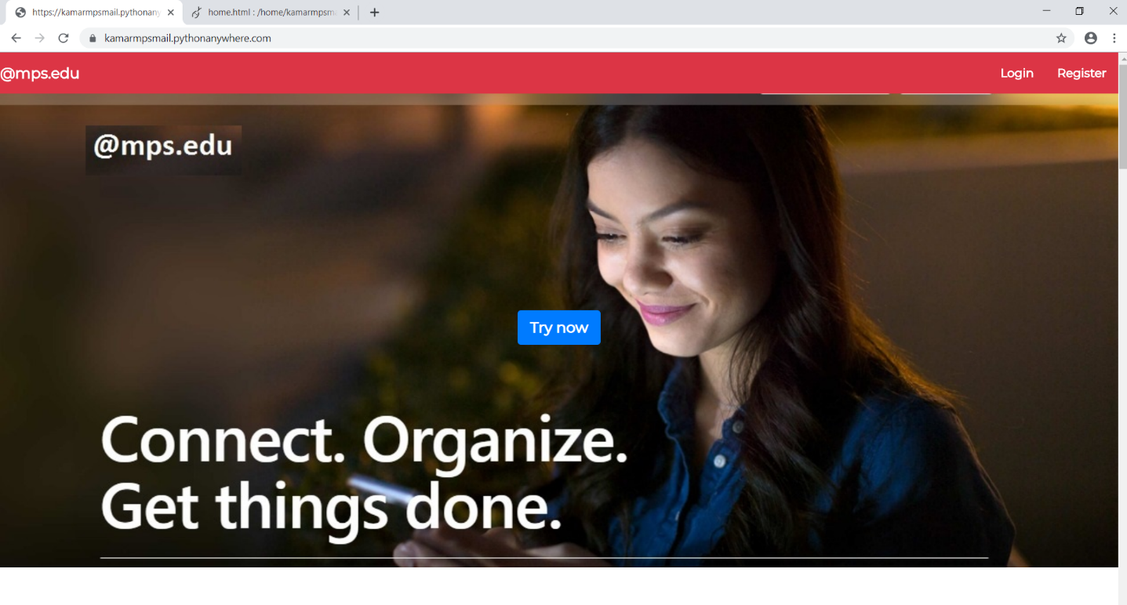



* 1. **REGISTRATION SCREEN**

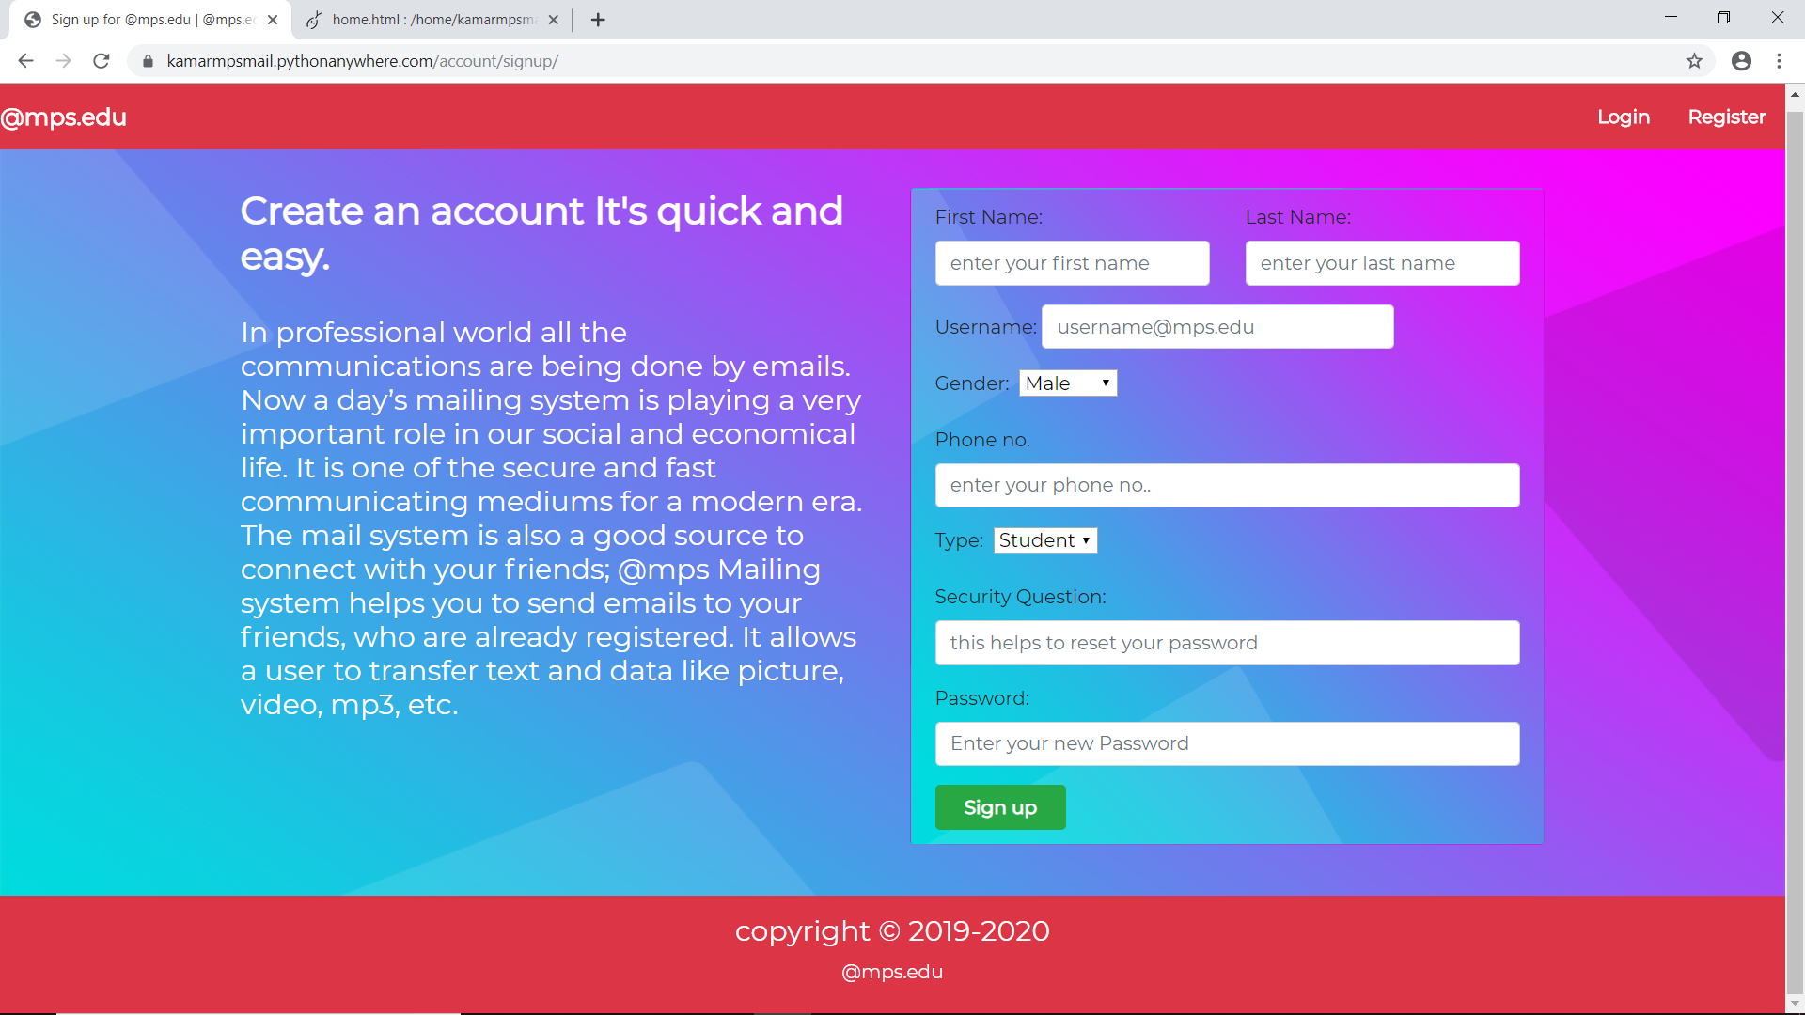

* 1. **LOGIN SCREEN**

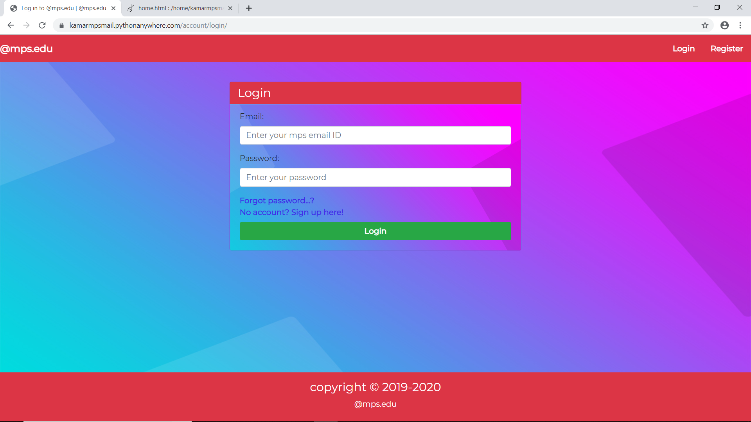

* 1. **INBOX SCREEN**

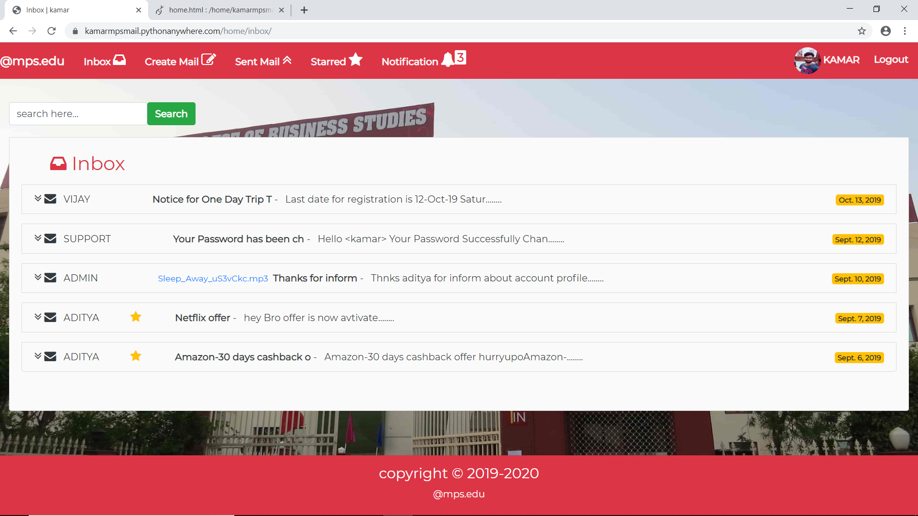

**6.5 INBOX VIEW1 SCREEN**

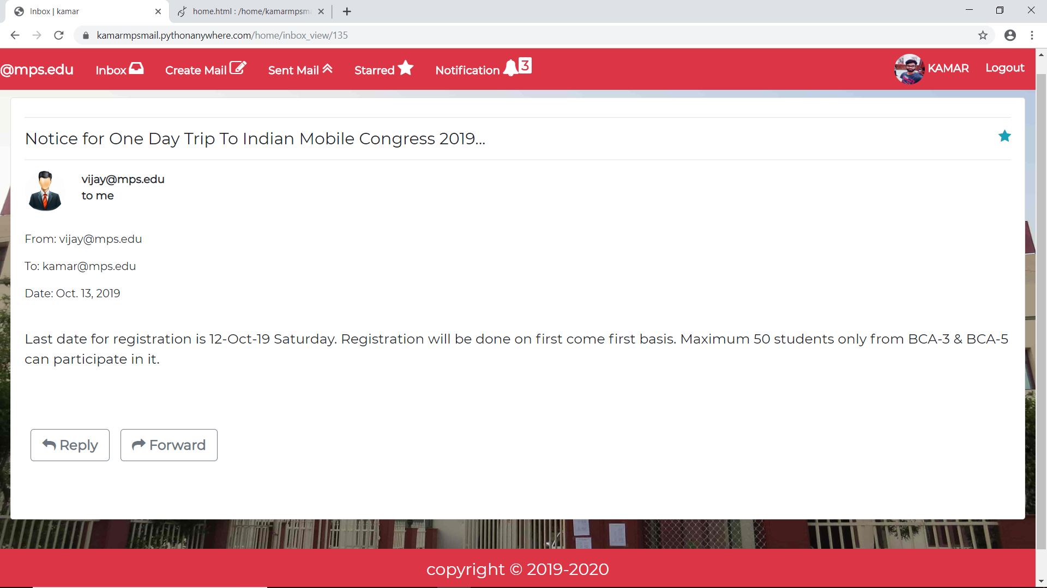

**6.5 INBOX VIEW2 SCREEN**

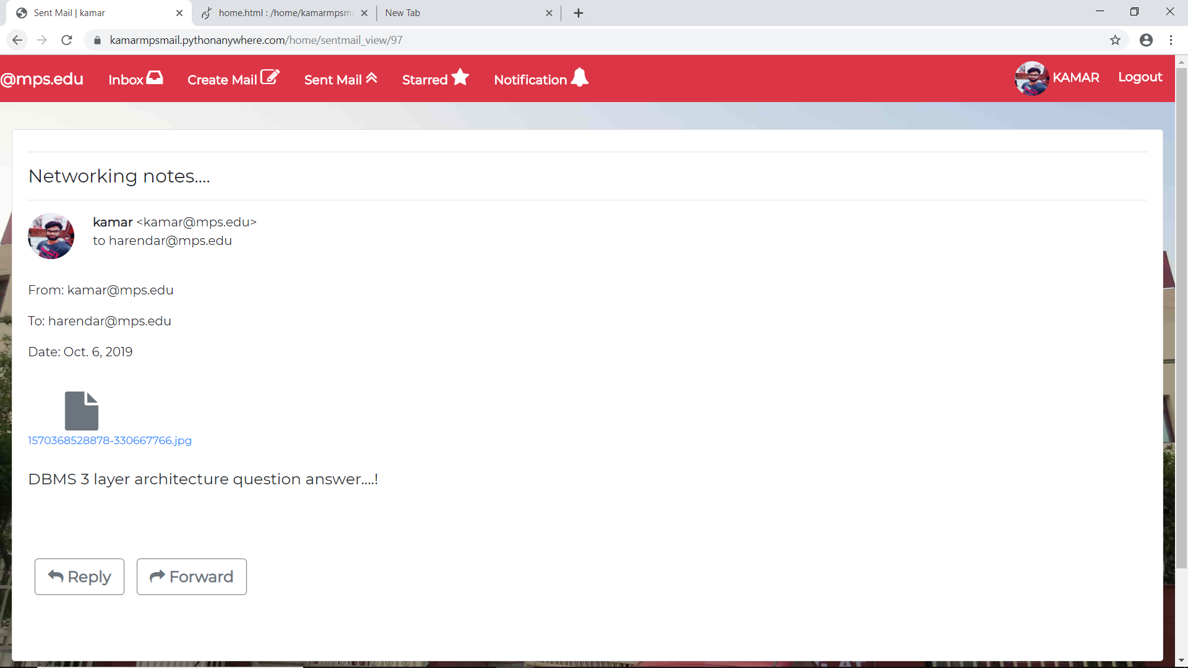

**6.6 NOTIFICATION SCREEN**

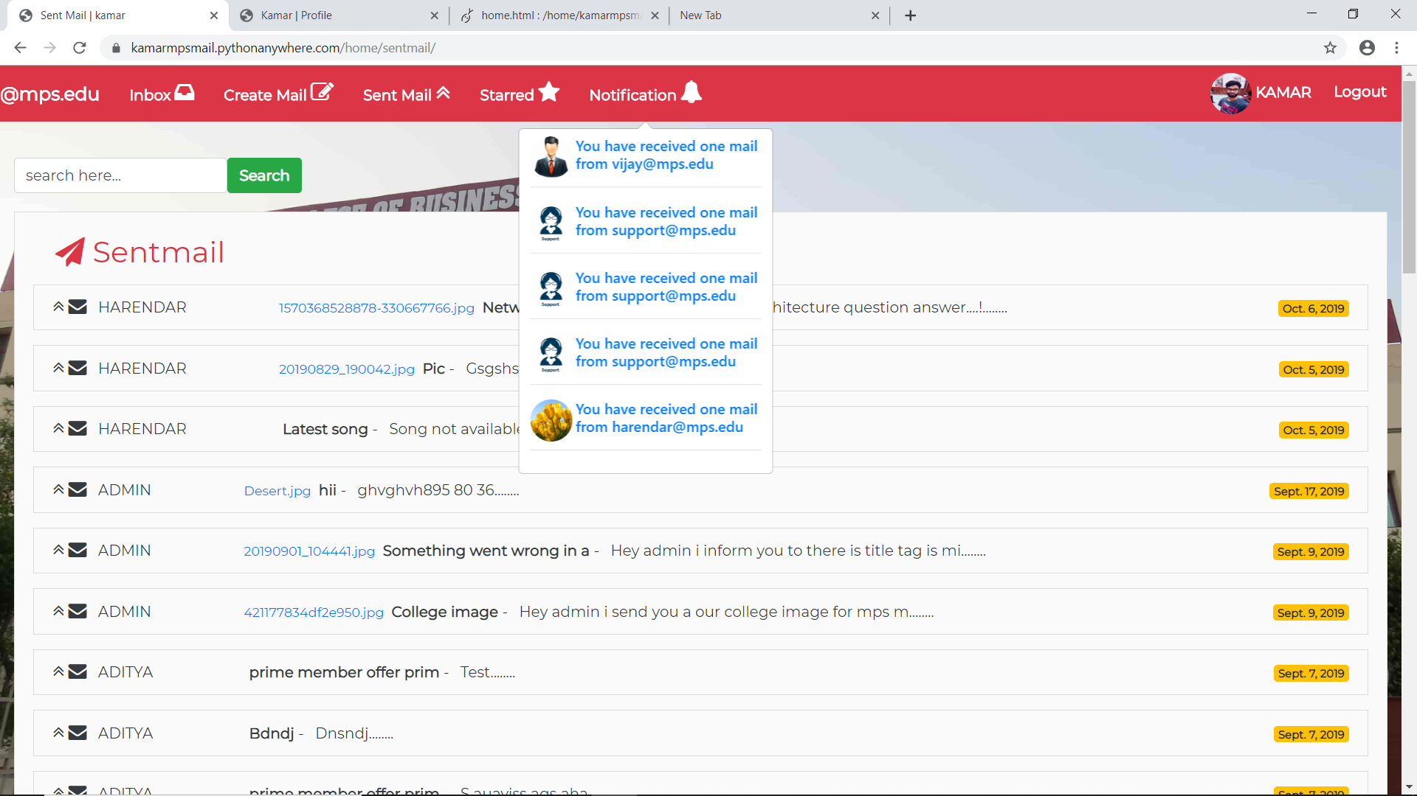



**6.7 COMPOSE MAIL SCREEN**

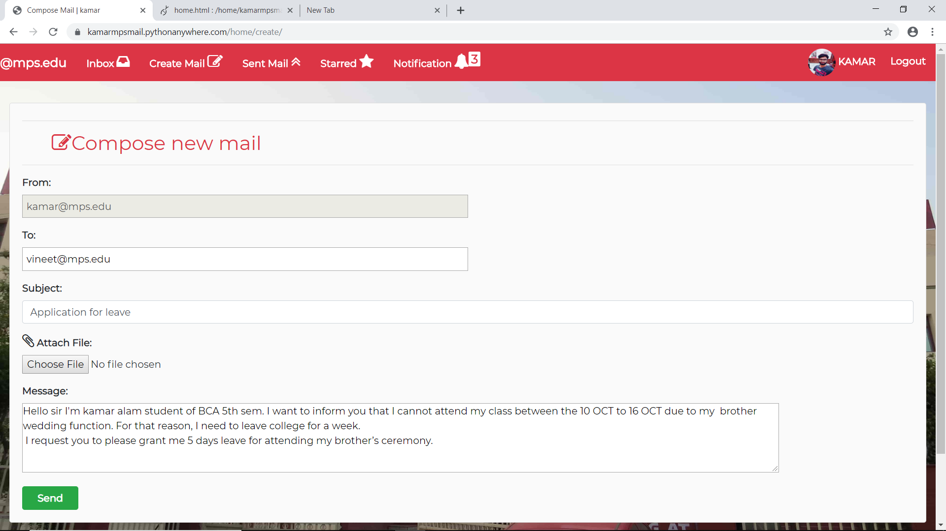

**6.8 PROFILE SCREEN**

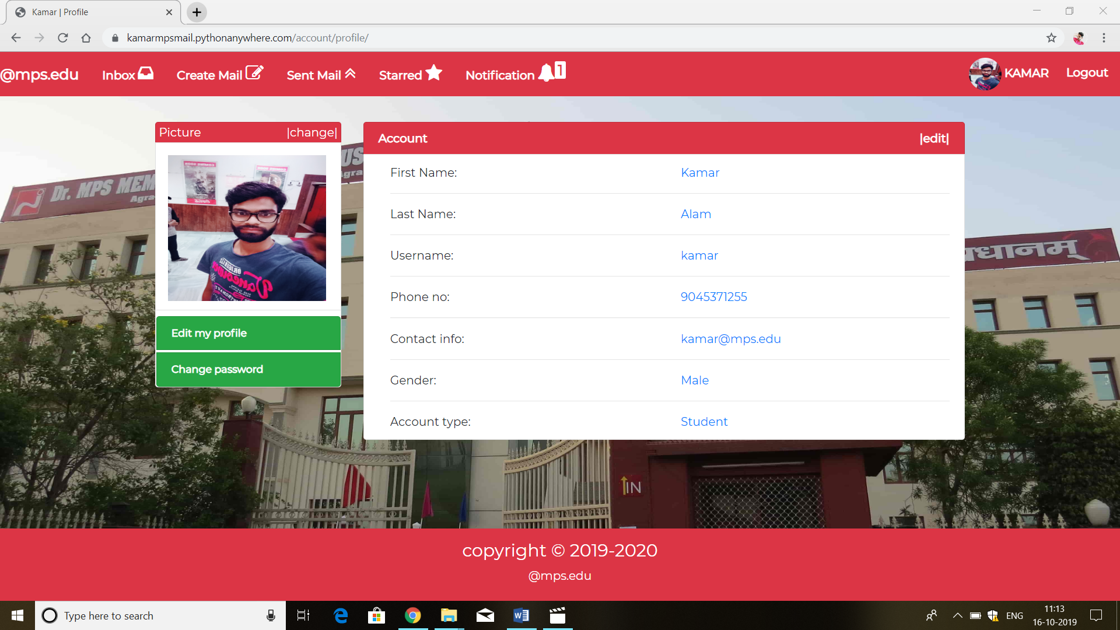**7: SOFTWARE USED**

…………..

**Sublime Text** is a proprietary cross-platform source code editor with a Python application programming interface (API). It natively supports many programming languages and markup languages, and functions can be added by users with plugins



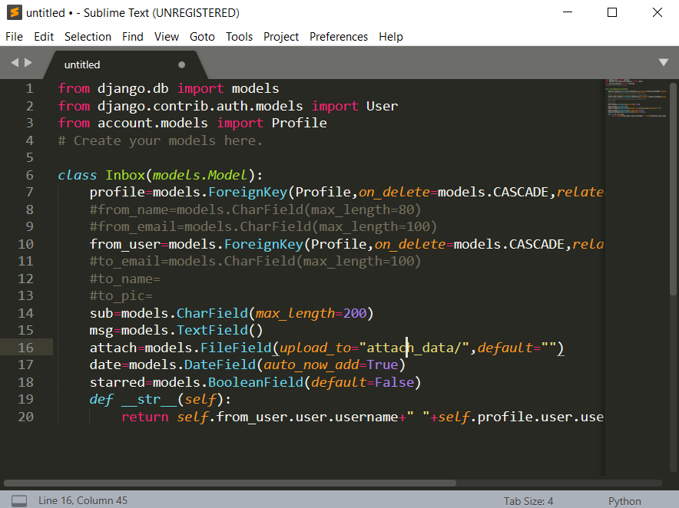

We use Sublime Text because it is very easy to operate code on the editor screen as it offers many features that helps in assigning quick actions like (code completion), code editor, integrated debugger and many other.



**8: TECHNOLOGY USED**

…………..

**8.1 Front End**



**1. HTML** (Hyper Text Markup Language): It is the markup language that is used to create HTML documents.

**2. CSS** (Cascading Style Sheets): It is a style sheet language. It is used to describe the look and format of a document written in a markup language.

**3. JavaScript:** It is a programming language for the web. JavaScript is mostly used as part of web browsers JavaScript can change and update both HTML and CSS.

**4. JQuery:** jQuery is a JavaScript library designed to simplify HTML DOM Element manipulation, as well as event handling.

**5. Bootstrap:** Bootstrap is the most popular CSS Framework for developing responsive and mobile-first websites.

6. **Ajax:** AJAX is a developer's dream, because you can, Read data from a web server - after a web page has loaded; update a web page without reloading the page



**8.2 Back End**



* **Python:** Python is an interpreted, high-level, general-purpose programming language. Python is dynamically typed and garbage-collected. It supports multiple programming paradigms, including procedural, object-oriented, and functional programming
* **Django:** Django is a high-level Python Web framework that encourages rapid development and clean, pragmatic design. Django follows the model-template-view (MTV) architectural pattern.
* **MySql:** MySQL is an Oracle-backed open source relational database management system (RDBMS) based on Structured Query Language (SQL), Used to create and manage database.



**10. TESTING**

…………..



**10.1 TEST CASES**

**CASE 1**

**Registration Screen**

**Description**: If a user want to register in mps mailing system, then user can easily create account in mps mailing system. After successfully register in mps mailing system then they automatically login in mps mailing system.

**Test Steps:**

Navigate to Registration form page.

In the Text Fields, enter the details of the user.

Click the Register button.

**Expected Result:** A User Automatically Login in mps mailing system.



**CASE 2**

**Login Screen**

**Description**: If a user want to use mps mailing system, then it must require to they login in mps mailing system. In order to login user must have mps Email ID and Password.

**Precondition:** User must have mps **Email ID** and **Password.**

**Test Steps:**

Navigate to Login form page.

In the Text Fields, enter the details of the user.

Click the Login button.

**Expected Result:** A User Login in mps mailing system.



**CASE 3**

**Compose Mail Screen**

**Description**: If a user want to send mail to another user then user must have Recipient email ID.

**Precondition:** User must have **Valid** **Recipient** **Email ID.**

**Test Steps:**

Navigate to Compose mail form page.

In the Text Fields, enter the details of the user.

Click the Send button.

**Expected Result:** A User get “**Mail Successfully Send to Recipient Email ID**” Like Message.



**CASE 4**

**Notification Screen**

**Description**: If user receive any mail, if user change profile detail and change password then, they get instant notification in notification menu.

**Precondition:** User must **Login** in mps mailing system**.**

**Test Steps:**

Navigate to Notification menu in any page.

Click the Notification menu.

Now click Notification which you want to see.

**Expected Result:** Show Notification To the Login User.



**CASE 5**

**Inbox Screen**

**Description**: If user receive mail then receive mail show in inbox page, This is the page where all your receive mails are present.

**Precondition:** User must **login** to see inbox page**.**

**Test Steps:**

Navigate to Inbox page.

Choose any mail which you want to see

Click the choose mail

**Expected Result:** If user have any mail then, mail display in inbox page.



**CASE 6**

**Profile Update Screen**

**Description**: If user want to change or update their information, then user can change their profile information in profile edit page.

**Precondition:** User must **login** to update or change profile**.**

**Test Steps:**

Navigate to Profile page.

Click Change Profile Option.

Now Change whatever you want.

Click the Update button.

**Expected Result:** User get message and Notification on If any information change on profile.



**11. FUTURE PROSPECTS**

…………..

If time and resource are available, then more features and functions are implemented in this system. Some of are as follow:

**Send Group Mail:** In this System we cannot send mail to group of student,

**Send Multiple File:** In this System we cannot send multiple file attachment, only one file send at a time.

**Custom Email ID**: Also we can implement custom Email ID, which means Every Branch Student have Email ID related to their Branch.

For example: BCA Student Email ID – [**Amit.BCA@mps.edu**](mailto:Amit.BCA@mps.edu)

BCOM Student Email ID – [**Amit.BCOM@mps.edu**](mailto:Amit.BCOM@mps.edu)

BBA Student Email ID – **Amit.BBA@mps.edu**



**12. Conclusion**

…………..

@mps mailing system is a user friendly system, which is very easy and convenient to use. The system is complete in the sense that it is operational and it is tested by entering data and getting the reports in proper order. But there is always a scope for improvement and enhancement. During the development of this coding standards are followed for easy maintainability and extensibility.

This Mailing System developed using python framework django fulfils the basic objectives of the system for which it has been developed.

The need of “**@MpsMailingSystem**” is increased day by day.

So this system is worked in proper way but there are some concepts which are necessary to implement for future use.

Mailing system basically comprises of a collection of names and addresses of affiliates of a college. It can act as a bridge between college and student or teacher and its affiliates to notify student and teacher affiliates of notice, seminar, events, meetings and upcoming schedules.



**13. REFERENCE/ BIBLIOGRAPHY**

…………..

1. **http://www.google.com**

It’s a search engine which is being used to search the require content in this project

1. **http://www.wikipedia.com**

This site is used to update and clear the knowledge required to complete this project like the concepts of designing diagrams and the definition of terms, ER, entity, etc.

1. **http://www.mail.google.com**

This site is used for understand how features of Gmail work.

1. **http://www.hotmail.com**

This site is used for show the demo how to work and designing the mail system etc.

1. **www.W3school.com**
2. Software Engineering by Dr. K.K. Agarwal

